What is physics- scientific methods-what physics has done for you lately---Video 1
Welcome to the world of physics!
Today’s video is going to be about answering the questions what is physics and what physics has done lately for you. We also are going to be exploring the scientific method and try to understand how the scientific change is viewed. I will also explain, in this motivational video, why in my opinion high school students have got the wrong vision of what physics can be and how there is no simple definition of this part of science.
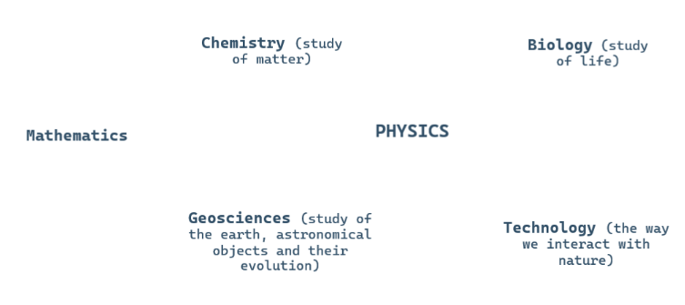^{[b][3][4][5]àààààààà}
Physics is more than a body of knowledge it is a way of thinking. Everything comes down to physics: chemistry for ex, is the study of the properties and behavior of matter: matter is eventually atoms and the way atoms interact is described by physics laws
Geology is the study of the earth, rocks and astronomical objects and how they evolve in time. The winds cycle comes eventually down to air flow and force exerted by one body on another which is also physics
Technology comes down to the way we interact with nature which is described by physics. So when you ask yourself the questions what has physics done for you lately, you have to be grateful for the dozens people who discovered everything in the history of our planet, and realize that the billion people have just glommed onto that or else we would be sitting in rolled up balls of dirt. Without, all the work performed bu those physicist on force, classical and fluid mechanics how would the industrial revi=olution or the internet revolution would have taken place. Here is an answer by the string theorist
How is the main questions physicist ask
Even if we may not now how science is going to evolve in the next few centuries, if youwant to understand the future you have to understand physics
The goal of physics is either to find a precise definition of measurable quantity such as kinetic energy, electromagnetic field or to discover some relations between those fundamental quantity. Scientist like Newton found that force=ma or Einstein with the famous E=mc². Those laws can be described using words, graphs, diagrams or some sort of model (like the Minkowski diagram to represent the motion of body : time and space axis = Einstein used it for special relativity). Mostly equations are used thanks to mathematics
Mathematics as the language or toolbox for physics
I like to think as math course in high school or college as learning tools to fill in your box and physics is where you’re going to take the right tools out and use them to solve problems
Eventually the purpose of physics is to find a simple and fundamental group of laws, one equations even to describe our entire universe. As R. Feynman said “Others… make guesses that are very complicated, and it sort of looks as if it's all right, but I know it's not true because the truth always turns out to be simpler than you thought.”What I find really interesting about phsics is that you are able to study the infinitly small and infinilty large at the same time and treating them not as opposite but as a whole.
What is even more interesting in physics is that the more discoveries and laws we prove the more questions comes up
Physics is divided into 3 sections: classical mechanics, quantum mechanics and relativity.
The history of physics can be decomposed into 3 periods ancient (that is medieval European and islmaic physics), classical and modern physics. Aristotle, who based physics on verbal argument principle of motion was unchanged until Neton came. Unfortunately they were false. They stated that object won’t stop until they get tired or that the speed was proportional to the weigh, theory of 4 matural elements. Although soe famous arav=bic scientist made some significant innovations in the field of optics such as Ibn al Haytham who wrote the book of optic who influenced many scientists from the Renaissance like Leonardo da Vinci, the science at this point of history was still deeply linked to the religion and the world was dominated by god. Physics reallu became a separate science with the Galileo revolution which began with the heliocentric theory, followed by the numerous breakthrough made by newton on universal gravitation and the laws of motion and optics. Then, new discoveries were made in the field of thermodynamics electricity and electromagnetism laws. Even though these were not completely accurate, they made the industrial revolution append and are still used today because they give good enough approximation most of the time. Modern physics began in the 20th century with scientists like Einstein (general and special relativity), Maxwell’s equations on electromagnetism, Planck and his length measurements system (the Planck units) very useful in quantum mechanics, the incertitude principle by Heisenberg, the standard model of physics which is a common contribution completed by the discovery of Higgs Boson at CERN in 2012. The discovery of new body like black hole studied by s. Hawking or dark matter is also part of modern physics. The goal of this modern physics is to find a unified theory to describe our universe not only at large scale but also at smaller scales
If you want to know more about the history of physics you can check out the video down bellow
Lately physicists have become either theoretical (they are responsible of finding theories)or experimental (they are responsible of proving theories) physicists
What impact has philosophy on physics
Up until the 18th century physics was known as a natural philosophy and scientist studied it as part of other sciences and until the contemporary period strongly influenced by the church’s thinking. It was not until the 19th century it became a distinct flied. It is still connected to and relying on philosophy. In some way physics has answered lots of questions of philosophic like the nature of time, methaphysical outlooks (multiverse and holograms…)Many scientist have written about the philosophical implications of physics
I want to finish this video by the 2 following quotes, which are going to keep you motivated to learn physics.
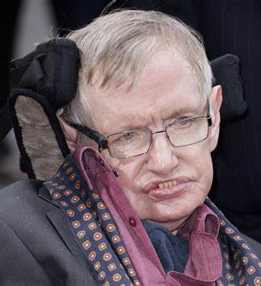
Stephen Hawking
Physics is just the truth of the universe
So, remember to look up at the stars and not down at your feet try to make sense of what you see and wonder about what makes the universe exist. Be curious and however difficult life may seem there is always something you can do and succeed at. It matters that you don’t just give up work. Work gives you meaning, and purpose and life is empty without it.

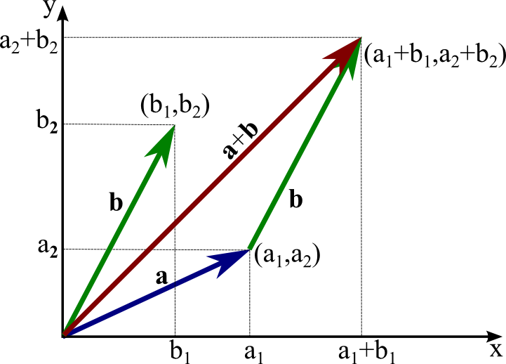
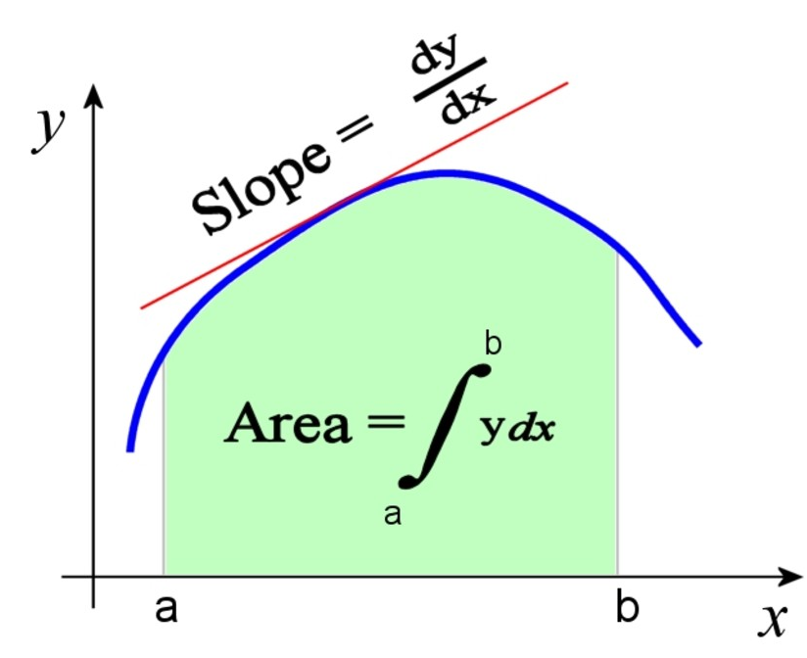
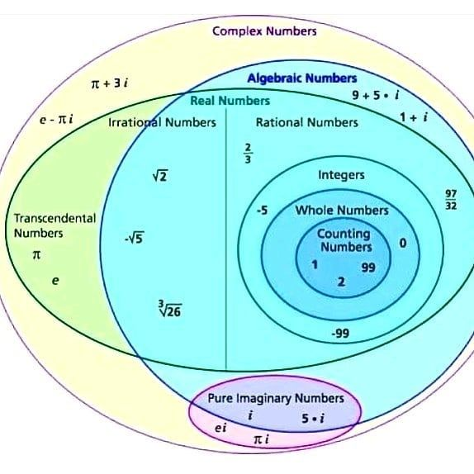
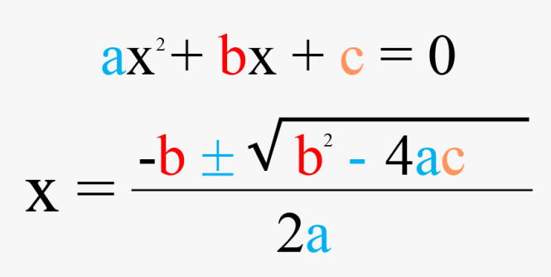
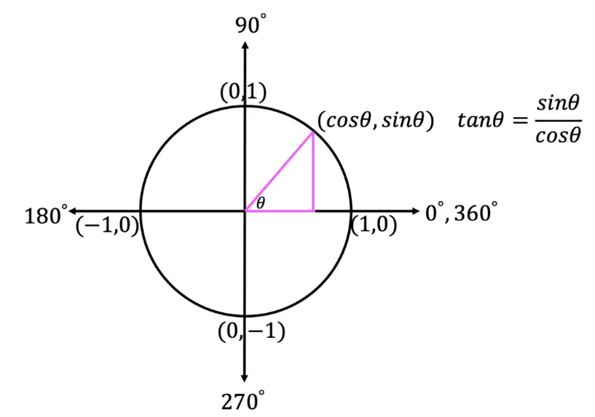
The toolbox of mathematics

